Kubernetes (K8s)
Complete Study Notes — Version 1.33
Container Orchestration | Architecture | Deployments

1. What is Kubernetes?
Kubernetes (K8s) is a platform that automatically runs, scales, and heals your containerized applications.

Kubernetes is an open-source container orchestration tool originally developed by Google. It helps you manage containerized (Dockerized) applications across multiple environments:
- On-premise servers
- Cloud platforms (AWS, GCP, Azure)
- Virtual machines

Key Features (Advantages)
- High availability — zero downtime for your applications
- High performance & scalability — handles growing workloads easily
- Reliable data recovery — infrastructure supports backup and restore

Disadvantages
- Complex to set up — takes significant time and expertise
- Infrastructure setup from scratch can be challenging

Kubernetes vs Docker Swarm
Kubernetes (K8s) | Docker Swarm
More features, complex setup | Simpler setup, fewer features
Better for large-scale production | Better for smaller deployments
Industry standard | Less widely adopted
Strong community & ecosystem | Limited ecosystem

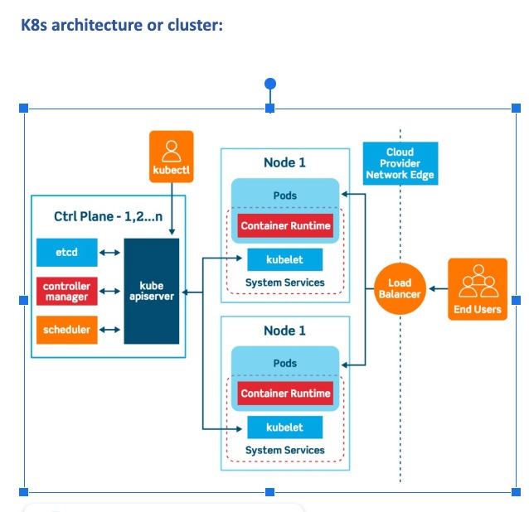
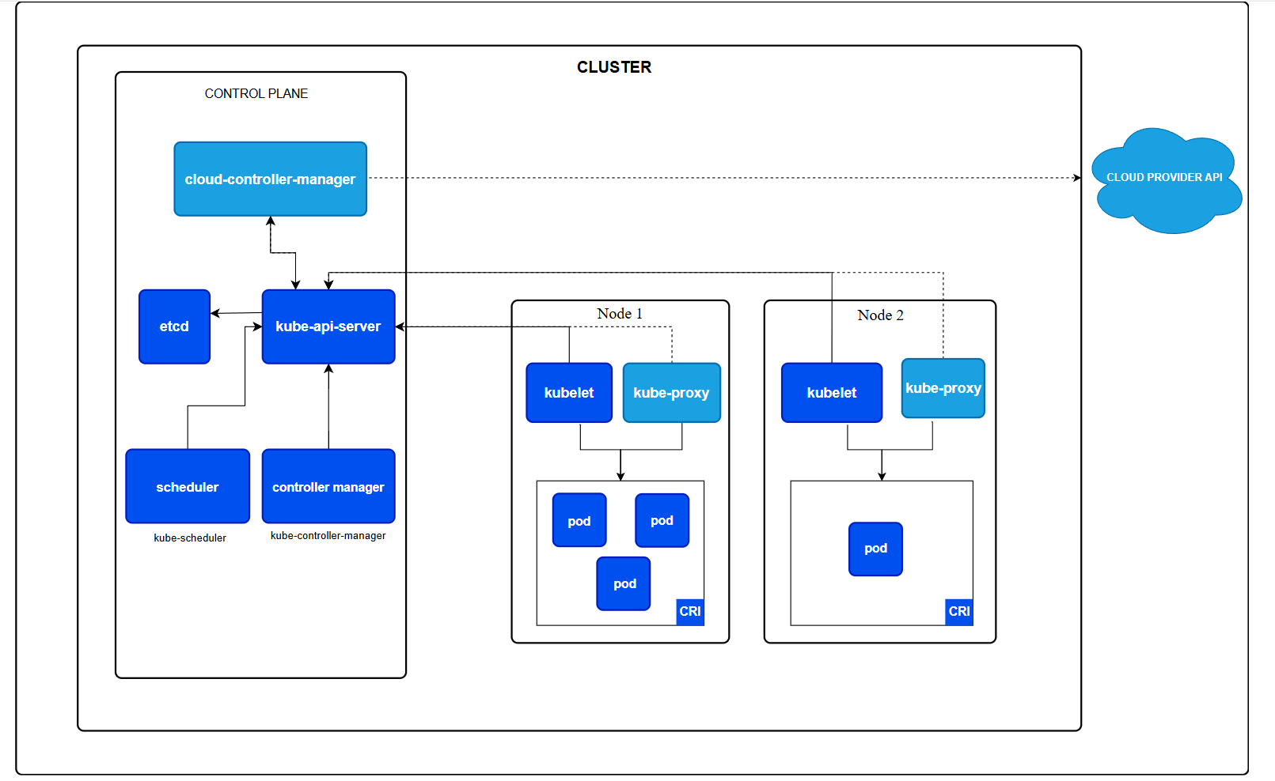

2. Kubernetes Architecture
A K8s cluster has TWO main components: the Master Node (control plane) and Worker Nodes.

Core Concepts
Term | Definition
Cluster | A collection of nodes (servers) pooling their CPU, RAM, and disk resources together
Node | A single machine (physical or virtual) that runs containers
Master Node | The control plane — manages and coordinates the whole cluster
Worker Node | Runs the actual application containers
Namespace | A virtual sub-cluster to isolate resources between teams or environments
Pod | The smallest deployable unit — wraps one or more containers

Master Node Components
The master node is the brain of the cluster. It handles all administrative tasks and cluster decisions.

1. API Server
- The central entry point for all cluster operations
- Receives REST requests and communicates with all other components
- Think of it as the 'front door' of your cluster

2. ETCD
- A distributed key-value store that holds all cluster configuration and state
- Acts as the cluster's 'memory' or metadata storage
- Example: stores data like { "name": "xyz", "part": "ght" }
- All components communicate through ETCD

3. Scheduler
- Decides which worker node should run a new Pod
- Considers resource availability (CPU, memory) on each node
- Distributes workload evenly across the cluster

4. Controller Manager
- A background service (daemon) running in a continuous loop
- Watches the cluster state and works to maintain the desired state
- Contains multiple sub-controllers:
- Node Controller — detects and responds when nodes go down
- Job Controller — creates Pods for one-off tasks
- EndpointSlice Controller — links Services to Pods
- ServiceAccount Controller — creates default accounts for new namespaces

5. kubectl
- The command-line tool you use to interact with Kubernetes
- Sends commands to the API server to manage the cluster

Worker Node Components
Worker nodes are where your actual applications run. Each worker node has three key components:

1. Kubelet
- An agent running on every worker node
- Gets Pod configuration from the API server
- Ensures the described containers are running and healthy

2. Kube-Proxy
- Acts as a network proxy and load balancer on the node
- Manages network rules and routes traffic to the right Pod

3. Container Runtime
- The engine that actually runs containers (e.g., Docker, containerd)
- Manages the full lifecycle of containers on the node

3. Namespaces
A Namespace is like a virtual cluster inside your Kubernetes cluster — used to separate and organize resources.

Namespaces help you isolate resources between different teams, projects, or environments (dev, staging, prod).

Advantages
- Easy management — separate apps per environment
- Control multiple apps with a single cluster (cost-effective)
- Apply resource quotas per namespace to prevent overuse

Default Namespaces
Namespace | Purpose
default | Objects created without specifying a namespace go here
kube-system | Core Kubernetes components (system-managed)
kube-public | Readable by everyone; reserved for system usage

4. Pods
A Pod is the smallest object in Kubernetes — it wraps one or more containers that share the same network and storage.

Pods are similar to a group of Docker containers with shared namespaces and file system volumes.

Pod Lifecycle
State | Meaning
Pending | Pod is created but containers haven't started yet (still scheduling/pulling image)
Running | All containers are running without issues
Terminated | Container finished execution — either completed successfully or failed

Creating a Pod (YAML)
Pods are defined using YAML files — a human-readable configuration format. Command: kubectl create -f filename.yaml

5. Services & Publishing
A Service exposes your Pods to traffic — either inside the cluster or to the outside world.

Service Type | What It Does
ClusterIP (default) | Exposes the service only within the cluster. Other Pods can reach it, but not external users.
NodePort | Exposes the service on a static port on each node's IP. Accessible from outside the cluster.
LoadBalancer | Uses a cloud provider's load balancer to expose the service externally. Best for production.
ExternalName / ExternalIP | Maps the service to an external DNS name using a CNAME record.

6. ReplicaSet
A ReplicaSet ensures that a specified number of identical Pod replicas are always running.

If a Pod crashes, the ReplicaSet automatically creates a new one to replace it.

Why Replicate Pods?
- Reliability
- If one Pod fails, others keep the app running
- Load Balancing
- Traffic is spread across multiple Pods — no single overload
- Scalability
- Easily scale up by adding more replicas when load increases

Tip: Use Deployments instead of ReplicaSets directly — they manage ReplicaSets and add rolling updates and rollback features.

7. Deployments
A Deployment lets you manage a set of identical Pods declaratively — just define the desired state in a YAML file and Kubernetes handles the rest.

What a Deployment Does
- Creates and manages Pods automatically
- Keeps Pods up to date with rolling updates
- Ensures the correct number of Pods are always running
- Supports rollback to previous versions

Rolling Updates
Kubernetes updates Pods gradually to avoid downtime:
- New Pods are created with the new version first
- Only after new Pods are healthy are old Pods shut down
- At least some instances stay up at all times

Setting | Meaning
maxSurge | Maximum number of extra Pods to create BEFORE removing old ones
maxUnavailable | Maximum number of Pods allowed to be down DURING an update

Quick Reference — Key Commands
These are the most common kubectl commands you'll use day-to-day.

Command | What It Does
kubectl get pods | List all Pods in the current namespace
kubectl get nodes | List all nodes in the cluster
kubectl get deployments | List all deployments
kubectl get services | List all services
kubectl create -f file.yaml | Create a resource from a YAML file
kubectl apply -f file.yaml | Create or update a resource from a YAML file
kubectl delete pod <name> | Delete a specific Pod
kubectl describe pod <name> | Show detailed info about a Pod
kubectl logs <pod-name> | View logs from a Pod
kubectl get namespaces | List all namespaces

Summary — The Big Picture
Here's how everything fits together:

- You write a Deployment YAML defining how many replicas of your app to run
- kubectl sends it to the API Server on the Master Node
- The Scheduler picks which Worker Nodes will run the Pods
- The Kubelet on each Worker Node starts the containers via the Container Runtime
- Kube-Proxy routes network traffic to the correct Pods
- ETCD stores all the state and configuration
- The Controller Manager continuously watches and fixes any drift from the desired state

Remember: Kubernetes goal is always to match the ACTUAL state of the cluster to the DESIRED state you defined.

02-Mar-2026

DaemonSet (short & simple)
DaemonSet is a Kubernetes object that makes sure one Pod runs on every node in the cluster.
Why it is used
- To run node-level services
- Automatically adds a Pod when a new node joins
- Removes the Pod when a node is deleted
Where it is used
DaemonSets are commonly used for:
- Logging (Fluentd, Fluent Bit)
- Monitoring (node-exporter, Datadog agent)
- Networking (kube-proxy, CNI plugins)
- Security agents (Falco, antivirus agents)

Kubernetes Scheduling & Storage – Organized Notes

1. Taints and Tolerations
Concept
Taints and tolerations work together to control which pods can run on specific nodes.
- Taints → Applied on nodes
- Tolerations → Applied on pods
If a node has a taint, pods without matching tolerations will not be scheduled on that node.
Important:
- Taints restrict nodes from accepting pods
- They do NOT force pods to go to a node

Syntax
kubectl taint nodes <node-name> key=value:taint-effect
Example:
kubectl taint nodes node1 color=pink:NoSchedule

Taint Effects
Effect | Meaning
NoSchedule | Pod will NOT be scheduled on node
PreferNoSchedule | Scheduler tries to avoid node
NoExecute | Pod will be evicted if already running

Example
Taint the node:
kubectl taint nodes node1 key1=value1:NoSchedule
Pod must have a matching toleration to run on that node.

When to Use
- Dedicated nodes for critical workloads
- GPU nodes
- Database nodes
- Isolation of system components

2. Node Selector
Concept
NodeSelector is the simplest way to schedule pods to specific nodes.
It works using node labels.
A pod will run on a node only if the node has the required label.

Step 1: Label the Node
kubectl label nodes node2.example.com size=large

Step 2: Use NodeSelector in Pod
Example Pod YAML:
apiVersion: v1
kind: Pod
metadata:
name: mypod
spec:
nodeSelector:
size: large
containers:
- name: nginx
image: nginx
Pod will only run on nodes labeled:
size=large

Limitations of NodeSelector
NodeSelector cannot handle complex rules such as:
❌ OR conditions
❌ NOT conditions
❌ Multiple advanced checks
Example not possible:
large OR medium but NOT small
For these scenarios, use Node Affinity.

3. Node Affinity (Advanced Scheduling)
Concept
Node affinity is more flexible and powerful than nodeSelector.
It allows:
- Complex conditions
- Logical operators
- Soft and hard rules

Types of Node Affinity
1️⃣ requiredDuringSchedulingIgnoredDuringExecution
Hard rule.
Pod must match the rule or it will stay Pending.
Example:
spec:
affinity:
nodeAffinity:
requiredDuringSchedulingIgnoredDuringExecution:
nodeSelectorTerms:
- matchExpressions:
- key: disktype
operator: In
values:
- ssd
Meaning:
Pod will run only on nodes with label
disktype=ssd

2️⃣ preferredDuringSchedulingIgnoredDuringExecution
Soft rule.
Scheduler tries to follow the rule, but can ignore it.
Example:
spec:
affinity:
nodeAffinity:
preferredDuringSchedulingIgnoredDuringExecution:
- weight: 1
preference:
matchExpressions:
- key: disktype
operator: In
values:
- ssd
Meaning:
Scheduler prefers SSD nodes, but may choose others.

Operators Used in Affinity
Operator | Meaning
In | Value must match
NotIn | Value must not match
Exists | Key must exist
DoesNotExist | Key must not exist
Gt | Greater than
Lt | Less than

4. Pod Affinity
Concept
Pod affinity controls which pods should be scheduled together.
Unlike node affinity:
Feature | Based On
Node Affinity | Node Labels
Pod Affinity | Pod Labels

Why Use Pod Affinity?
- Reduce network latency
- Keep microservices close
- Improve data locality
- Optimize service communication
Example:
Frontend pods should run near backend pods.

Hard Pod Affinity
requiredDuringSchedulingIgnoredDuringExecution
Pod must be scheduled near matching pods, otherwise it stays Pending.
Example:
apiVersion: v1
kind: Pod
metadata:
name: frontend
spec:
affinity:
podAffinity:
requiredDuringSchedulingIgnoredDuringExecution:
- labelSelector:
matchExpressions:
- key: app
operator: In
values:
- backend
topologyKey: topology.kubernetes.io/zone
Meaning:
Frontend pod will run in the same zone as backend pods.

Important Field: topologyKey
Defines how close pods must be.
topologyKey | Meaning
kubernetes.io/hostname | Same node
topology.kubernetes.io/zone | Same zone
topology.kubernetes.io/region | Same region

5. Pod Anti-Affinity
Concept
Opposite of Pod Affinity.
Used to spread pods across nodes.
Purpose:
- High availability
- Fault tolerance
- Avoid single point of failure

Example
affinity:
podAntiAffinity:
requiredDuringSchedulingIgnoredDuringExecution:
- labelSelector:
matchLabels:
app: frontend
topologyKey: kubernetes.io/hostname
Meaning:
Do NOT place two frontend pods on the same node.

Use Cases
Scenario | Use
Microservices communication | Pod Affinity
High availability | Pod Anti-Affinity
Web replicas spreading | Anti-Affinity
Database + cache together | Affinity

6. Designing HA and Workload Isolation
Interview Answer:
Question:
How would you design HA and workload isolation in Kubernetes?
Answer:
Use:
- Taints → isolate critical nodes
- Node Affinity → enforce pod placement
- Pod Anti-Affinity → spread replicas across nodes
- Pod Affinity → keep related services close

7. hostPath Volume
Concept
hostPath mounts a file or directory from the node into a pod.
It is similar to Docker bind mount.
Example:
Pod can access:
/var/log
from the host machine.

hostPath Types
Type | Meaning
Directory | Must exist
DirectoryOrCreate | Create if not exists
File | Must exist
FileOrCreate | Create if not exists
Socket | Unix socket
CharDevice | Character device
BlockDevice | Block device

When to Use hostPath
✅ Development
✅ Single node clusters (Minikube)
✅ Access node logs
✅ System monitoring agents

When NOT to Use
❌ Production multi-node clusters
❌ Applications needing portability

Why hostPath is Risky
- Pod tied to specific node
- Not portable
- Security risk (access host filesystem)

Production Alternative
Use:
- PersistentVolume (PV)
- PersistentVolumeClaim (PVC)
- Network Storage
- Cloud Storage (AWS EBS / GCP PD / Azure Disk)

8. AWS EBS CSI Storage Setup
Step 1: Install AWS Cloud Controller Manager
helm install aws-cloud-controller-manager aws-cloud-controller-manager/aws-cloud-controller-manager \
--namespace kube-system \
--create-namespace \
--values aws-ccm-values.yaml
Check status:
helm status aws-cloud-controller-manager -n kube-system

Step 2: Install EBS CSI Driver
helm repo add aws-ebs-csi-driver https://kubernetes-sigs.github.io/aws-ebs-csi-driver
helm repo update
Install:
helm install aws-ebs-csi-driver aws-ebs-csi-driver/aws-ebs-csi-driver \
-n kube-system \
--create-namespace

9. StorageClass Example
Create file:
ebs-sc.yaml
apiVersion: storage.k8s.io/v1
kind: StorageClass
metadata:
name: ebs-sc
provisioner: ebs.csi.aws.com
volumeBindingMode: WaitForFirstConsumer
reclaimPolicy: Delete
parameters:
type: gp3
fsType: ext4
encrypted: "true"
Apply:
kubectl apply -f ebs-sc.yaml

10. PersistentVolumeClaim (PVC)
Example:
apiVersion: v1
kind: PersistentVolumeClaim
metadata:
name: ebs-test-pvc
spec:
storageClassName: ebs-sc
accessModes:
- ReadWriteOnce
resources:
requests:
storage: 1Gi
Apply:
kubectl apply -f ebs-test-pvc.yaml
kubectl get pvc
Once bound → volume is created automatically.

11. Mount PVC in Pod
Example:
apiVersion: v1
kind: Pod
metadata:
name: ebs-test-pod
spec:
containers:
- name: app
image: nginx
volumeMounts:
- name: ebs-vol
mountPath: /usr/share/nginx/html
volumes:
- name: ebs-vol
persistentVolumeClaim:
claimName: ebs-test-pvc
This mounts EBS storage inside the container.

12. Storage Types Comparison
Feature | Object Storage | Block Storage | File Storage
Structure | Objects | Raw blocks | Files & folders
Hierarchy | Flat | No | Yes
Scaling | Massive | Limited | Moderate
Best For | Backups, media | Databases | Shared drives
Examples:
Type | Example
Object | S3
Block | EBS
File | EFS

Quick Revision Summary
Feature | Purpose
Taints | Restrict nodes
Tolerations | Allow pods on tainted nodes
NodeSelector | Simple node scheduling
NodeAffinity | Advanced node scheduling
PodAffinity | Place related pods together
PodAntiAffinity | Spread pods for HA
hostPath | Mount host directory
PV/PVC | Persistent storage
StorageClass | Dynamic volume provisioning
EBS CSI | AWS block storage for Kubernetes

To understand Kubernetes storage properly, you need clarity on these 4 things:
- PV (PersistentVolume)
- PVC (PersistentVolumeClaim)
- EBS (Elastic Block Store)
- EFS (Elastic File System)
I'll explain them step-by-step in a practical DevOps way so you can use them in real clusters and answer interview questions confidently.

1. Why Kubernetes Needs Persistent Storage
By default, containers are ephemeral.
Meaning:
- When a Pod restarts
- When a Pod is deleted
- When a Pod moves to another node
➡️ All data inside the container is lost
Example:
Pod running MySQL
Data stored in /var/lib/mysql
Pod crashes
New pod created
Data is gone ❌
So Kubernetes provides persistent storage using volumes.

2. Kubernetes Storage Architecture
Application Pod
│
│ uses
▼
PVC (PersistentVolumeClaim)
│
│ binds to
▼
PV (PersistentVolume)
│
│ backed by
▼
Storage Provider
(EBS / EFS / NFS / GCE Disk / Azure Disk)
Think of it like storage request system.
Component | Role
PV | Actual storage resource
PVC | Request for storage
Pod | Uses the storage

3. PersistentVolume (PV)
Definition
A PersistentVolume is a storage resource in the cluster.
It can be backed by:
- AWS EBS
- AWS EFS
- NFS
- Ceph
- Local disk
PV is created by:
- Admin (static provisioning)
- StorageClass automatically (dynamic provisioning)

PV Example
apiVersion: v1
kind: PersistentVolume
metadata:
name: pv-ebs
spec:
capacity:
storage: 5Gi
accessModes:
- ReadWriteOnce
awsElasticBlockStore:
volumeID: vol-123456
fsType: ext4
This PV uses:
AWS EBS volume

Important PV Fields
Field | Meaning
capacity | Storage size
accessModes | How pods can access
persistentVolumeReclaimPolicy | What happens after release
storageClassName | Storage class used
volumeMode | Block or filesystem

4. Access Modes
These are very important in interviews.
Access Mode | Meaning
ReadWriteOnce (RWO) | One node can read/write
ReadOnlyMany (ROX) | Multiple nodes read only
ReadWriteMany (RWX) | Multiple nodes read/write

Example:
Storage | Access Mode
EBS | RWO
EFS | RWX

5. PersistentVolumeClaim (PVC)
Definition
PVC is a request for storage by a user or pod.
PVC asks for:
- Storage size
- Access mode
- Storage class
Kubernetes then finds a matching PV.

PVC Example
apiVersion: v1
kind: PersistentVolumeClaim
metadata:
name: my-pvc
spec:
accessModes:
- ReadWriteOnce
resources:
requests:
storage: 5Gi
PVC will bind to a matching PV.

Binding Process
PVC Request
│
▼
Kubernetes searches for PV
│
▼
Matching PV found
│
▼
PVC ↔ PV Bound
Check:
kubectl get pvc

6. Using PVC in a Pod
Example:
apiVersion: v1
kind: Pod
metadata:
name: nginx-pod
spec:
containers:
- name: nginx
image: nginx
volumeMounts:
- mountPath: "/usr/share/nginx/html"
name: storage
volumes:
- name: storage
persistentVolumeClaim:
claimName: my-pvc
Now:
Pod → PVC → PV → Storage

7. Static vs Dynamic Provisioning
Static Provisioning
Admin creates PV manually.
Admin → creates PV
User → creates PVC
Problem:
- Manual
- Not scalable

Dynamic Provisioning (Recommended)
PV created automatically using StorageClass.
PVC created
│
StorageClass creates PV automatically
│
PVC binds to PV

8. StorageClass
StorageClass defines how storage should be provisioned.
Example:
apiVersion: storage.k8s.io/v1
kind: StorageClass
metadata:
name: ebs-sc
provisioner: ebs.csi.aws.com
parameters:
type: gp3
PVC referencing this class will create EBS automatically.

9. AWS EBS (Elastic Block Store)
What is EBS?
EBS is block storage for EC2 instances.
Think of it as virtual hard disk.
Example:
EC2 Instance
│
Attached
▼
EBS Volume

EBS in Kubernetes
Kubernetes attaches EBS to nodes.
Pod
│
Node
│
Attached EBS

Characteristics
Feature | Description
Type | Block storage
Performance | High
Access Mode | ReadWriteOnce
Sharing | Not easily shareable
Best for | Databases

Example Workloads
- MySQL
- PostgreSQL
- MongoDB
- Elasticsearch

10. AWS EFS (Elastic File System)
What is EFS?
EFS is network file storage.
Multiple machines can mount it simultaneously.
EC2 Node 1
EC2 Node 2
EC2 Node 3
│
▼
EFS

Characteristics
Feature | Description
Type | File storage
Access Mode | ReadWriteMany
Sharing | Multiple nodes
Performance | Moderate
Best for | Shared storage

Example Workloads
- Shared application files
- WordPress uploads
- Logs
- Media storage
- Microservices sharing data

11. EBS vs EFS
Feature | EBS | EFS
Type | Block | File
Access | One node | Many nodes
Performance | High | Moderate
Use case | Databases | Shared storage
Access Mode | RWO | RWX

12. Real Kubernetes Architecture Example
Example for WordPress + MySQL.
WordPress Pods
│
▼
EFS
(shared uploads)

MySQL Pod
│
▼
EBS
(database storage)
Reason:
- WordPress needs shared storage
- MySQL needs fast disk

13. Volume Reclaim Policy
Defines what happens after PVC is deleted.
Policy | Meaning
Retain | Keep storage
Delete | Delete storage
Recycle | Clean and reuse (deprecated)
Example:
persistentVolumeReclaimPolicy: Delete

14. Volume Binding Mode
Important for cloud volumes.
Example:
volumeBindingMode: WaitForFirstConsumer
Meaning:
Volume created only when pod is scheduled.
This avoids wrong zone creation in AWS.

15. Real DevOps Interview Questions
Question
Difference between PV and PVC?
Answer:
PV | PVC
Actual storage | Request for storage
Created by admin | Created by user
Cluster resource | Namespace resource

Question
When would you use EFS over EBS?
Answer:
Use EFS when multiple pods need shared storage across nodes, such as web uploads or shared configuration.

Question
Why does EBS use RWO?
Answer:
Because EBS is block storage attached to a single node.

16. Best Practices
✔ Use dynamic provisioning
✔ Use StorageClass
✔ Use EBS for databases
✔ Use EFS for shared storage
✔ Avoid hostPath in production

17. Quick Memory Trick
PV = Storage
PVC = Storage Request
SC = Storage Template
Pod
↓
PVC
↓
PV
↓
Storage (EBS / EFS)

05-Mar-2026
In Kubernetes, a ConfigMap is used to store non-sensitive configuration data that your containers need.
Examples of configuration data:
Environment variables
Application config files
Command-line arguments
URLs, ports, feature flags
A ConfigMap in Kubernetes is an API object used to store non-confidential configuration data as key-value pairs, decoupling config from container images.
⚡ Important Kubernetes Concept (Interview Question)
ConfigMap updates behave differently depending on mount type:
Mount Type | ConfigMap Update
Mounted as directory | Updates automatically
Mounted with subPath | Requires pod restart

Kubernetes Secrets
Secrets store sensitive data (passwords, tokens, keys) similarly to ConfigMaps, but with base64 encoding and access controls.
kubectl create secret generic my-secret \
--from-literal=DB_PASSWORD=supersecret \
--from-literal=API_KEY=abc123
Bash kubectl create secret generic my-secret --from-file=ssh-privatekey=~/.ssh/id_rsa
What are the two ways Kubernetes can pull private images?
Answer:
- imagePullSecrets in Pod/Deployment
- Attach secret to ServiceAccount

06-Mar-2026
Create Docker Registry Secret
Use your Docker Hub username and password (or access token).
kubectl create secret docker-registry dockerhub-secret \
--docker-server=https://index.docker.io/v1/ \
--docker-username=<dockerhub-username> \
--docker-password=<dockerhub-password> \
--docker-email=<email>

Use Secret in Pod
Add imagePullSecrets in the Pod spec.
apiVersion: v1
kind: Pod
metadata:
name: private-image-pod
spec:
containers:
- name: myapp
image: myuser/private-image:latest
imagePullSecrets:
- name: dockerhub-secret
Main Types of Kubernetes Secrets
Kubernetes supports several built-in secret types.
Secret Type Purpose
Opaque Generic secret (default)
kubernetes.io/dockerconfigjson Docker registry authentication
kubernetes.io/basic-auth Username/password authentication
kubernetes.io/ssh-auth SSH private keys
kubernetes.io/tls TLS certificates
kubernetes.io/service-account-token Service account authentication

kubectl create secret generic postgres-secret \
--from-literal=POSTGRES_PASSWORD=mysecurepassword

Use Secret in PostgreSQL Pod
apiVersion: v1
kind: Pod
metadata:
name: postgres-pod
spec:
containers:
- name: postgres
image: postgres:15
ports:
- containerPort: 5432
env:
- name: POSTGRES_PASSWORD
valueFrom:
secretKeyRef:
name: postgres-secret
key: POSTGRES_PASSWORD
Secret for Database Password
apiVersion: v1
kind: Secret
metadata:
name: postgres-secret
type: Opaque
stringData:
POSTGRES_PASSWORD: mypassword
How It Works
Secret (postgres-secret)
↓
Env Variable POSTGRES_PASSWORD
↓
PostgreSQL container
↓
Database starts with that password

apiVersion: v1
kind: Pod
metadata:
name: postgres-pod
spec:
containers:
- name: postgres
image: postgres:15
ports:
- containerPort: 5432
volumeMounts:
- name: postgres-secret-volume
mountPath: /etc/secrets
readOnly: true
volumes:
- name: postgres-secret-volume
secret:
secretName: postgres-secret
A StatefulSet in Kubernetes is used for applications that need stable network identity, persistent storage, and ordered deployment, such as databases like PostgreSQL, MySQL, Kafka, etc.
Unlike a Deployment, each pod in a StatefulSet gets:
Stable pod name (pod-0, pod-1)
Stable storage (Persistent Volume)
Stable DNS name

Headless Service (Required for StatefulSet)
StatefulSets use a Headless Service for stable DNS.
apiVersion: v1
kind: Service
metadata:
name: postgres
spec:
clusterIP: None
selector:
app: postgres
ports:
- port: 5432
StatefulSet with Persistent Volume
apiVersion: apps/v1
kind: StatefulSet
metadata:
name: postgres
spec:
serviceName: postgres
replicas: 2
selector:
matchLabels:
app: postgres
template:
metadata:
labels:
app: postgres
spec:
containers:
- name: postgres
image: postgres:15
ports:
- containerPort: 5432
env:
- name: POSTGRES_PASSWORD
valueFrom:
secretKeyRef:
name: postgres-secret
key: POSTGRES_PASSWORD
volumeMounts:
- name: postgres-storage
mountPath: /var/lib/postgresql/data
volumeClaimTemplates:
- metadata:
name: postgres-storage
spec:
accessModes: ["ReadWriteOnce"]
resources:
requests:
storage: 1Gi

Stable DNS Names
Pods get DNS names like:
postgres-0.postgres.default.svc.cluster.local
postgres-1.postgres.default.svc.cluster.local

Headless Service
│
StatefulSet
│
┌───────────────┐
│ │
postgres-0 postgres-1
│ │
PVC-0 PVC-1
│ │
PV-0 PV-1

When to Use StatefulSet
Use StatefulSet for:
Databases (Postgres, MySQL)
Kafka
Zookeeper
Elasticsearch
Use Deployment for:
Stateless apps
APIs
Frontend apps

In Kubernetes, to limit the number of Pods in a namespace, you use ResourceQuota, not LimitRange.
LimitRange → controls CPU/Memory per pod/container
ResourceQuota → controls total resources in a namespace (including pod count)

apiVersion: v1
kind: ResourceQuota
metadata:
name: pod-quota
namespace: dev
spec:
hard:
pods: "5"
apiVersion: v1
kind: ResourceQuota
metadata:
name: namespace-quota
namespace: dev
spec:
hard:
pods: "10"
requests.cpu: "4"
requests.memory: 8Gi
limits.cpu: "8"
limits.memory: 16Gi

apiVersion: v1
kind: Pod
metadata:
name: guaranteed-pod
spec:
containers:
- name: app
image: nginx
resources:
requests:
cpu: "500m"
memory: "256Mi"
limits:
cpu: "500m"
memory: "256Mi"
In Kubernetes, QoS (Quality of Service) Classes determine how Kubernetes prioritizes pods when the node runs out of resources like CPU or memory.
Kubernetes automatically assigns a QoS class to each Pod based on its resource requests and limits.
There are 3 QoS classes:
1️⃣ Guaranteed
2️⃣ Burstable
3️⃣ BestEffort

Guaranteed QoS
A Pod gets Guaranteed QoS when:
CPU request = CPU limit
Memory request = Memory limit
Defined for all containers
BestEffort QoS
A Pod gets BestEffort when:
No requests
No limits
Burstable QoS
A Pod gets Burstable QoS when:
Requests and limits are defined
But requests ≠ limits
BestEffort QoS
A Pod gets BestEffort when:
No requests
No limits
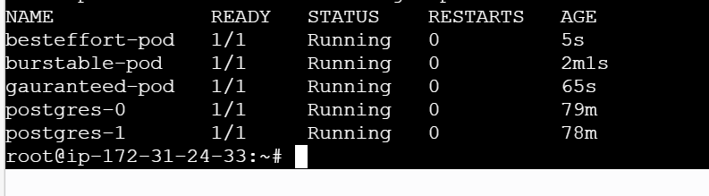
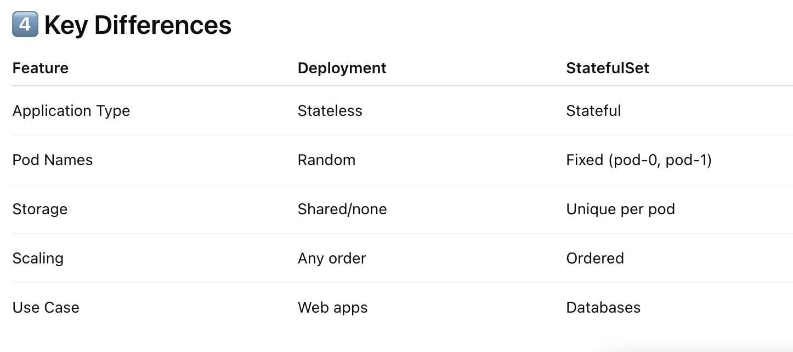
Networking:
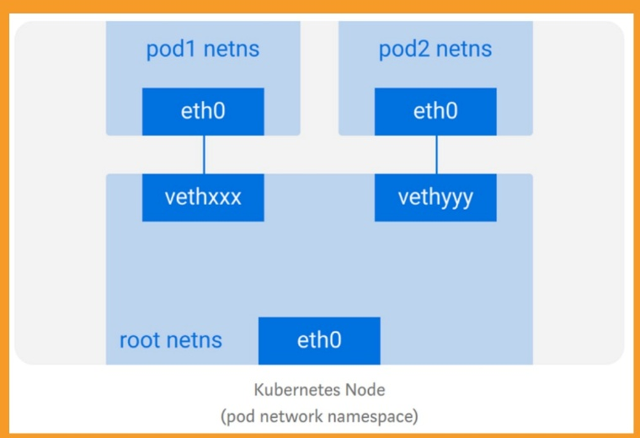

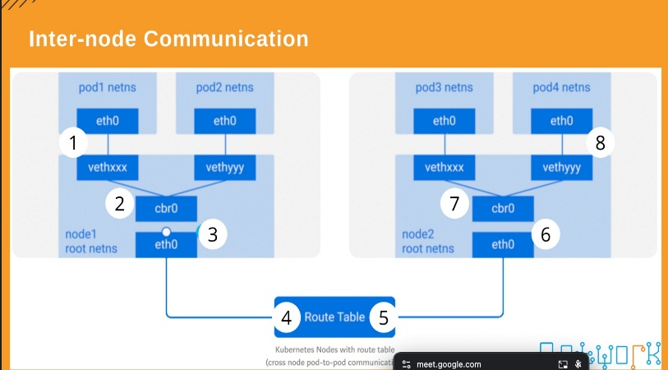

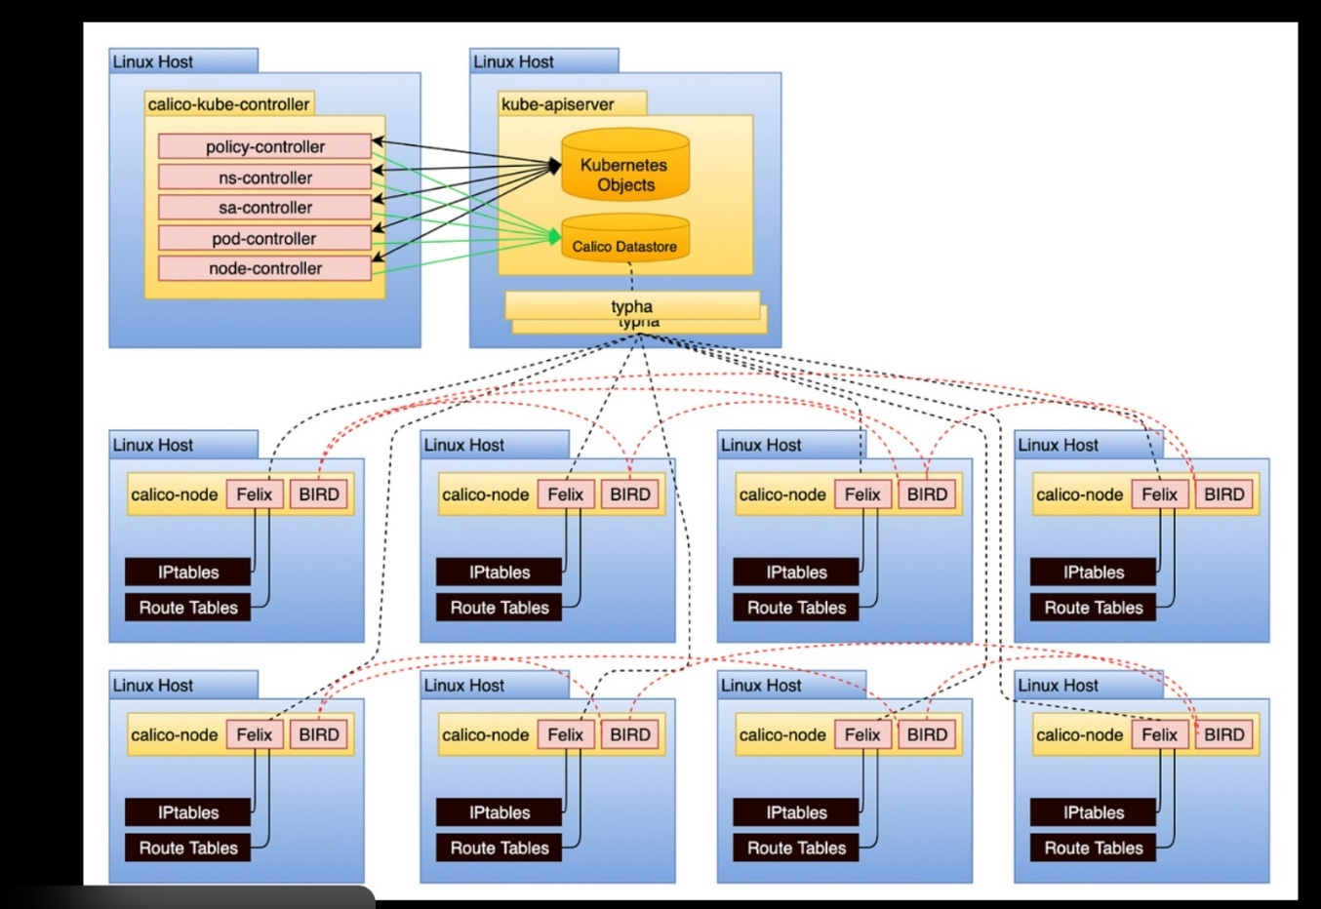
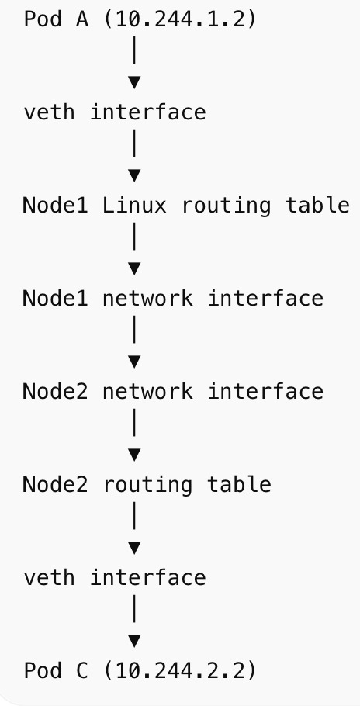
Pod → Service → kube-proxy → iptables → CNI → destination pod

Communication between containers in the same pod
Communication between pods on the same node
Communication between pods on different nodes
Communication between pods and services
How does DNS work? How do we discover IP addresses?
1 Communication Between Containers in the Same Pod
Key Idea: Containers in the same pod share the same network namespace.
Features
Same IP address
Same port space
Can communicate using localhost
Example
Pod
├── Container A
└── Container B

Communication:
Container A → localhost:8080 → Container B
Example use case:
App container + Sidecar container
2️⃣ Communication Between Pods on the Same Node
Each pod has its own IP address.
Example:
Node1
├── Pod A → 10.244.1.2
└── Pod B → 10.244.1.3
Communication:
Pod A → 10.244.1.3 → Pod B
How it works:
Pod A
↓
veth pair (Virtual ethernet pair - Virtual cable)
↓
Linux bridge / CNI
↓
Pod B
Networking is handled by the CNI plugin (example: Calico).
3️⃣ Communication Between Pods on Different Nodes
Example:
Node1 Node2
Pod A Pod B
10.244.1.2 10.244.2.2
Communication flow:
Pod A
↓
Node1 routing table
↓
Cluster network
↓
Node2 routing table
↓
Pod B
CNI plugin handles routing between nodes.
Example technologies:
Calico → BGP routing
Flannel → VXLAN overlay
4️⃣ Communication Between Pods and Services
Pods are temporary, so Kubernetes uses Services to provide stable access.
Example:
Frontend Pod
│
▼
Service (ClusterIP)
│
┌────┴─────┐
▼ ▼
Pod A Pod B
How it works:
Pod → Service IP → kube-proxy → Backend Pod
Service provides:
Stable IP
Load balancing
DNS name
5️⃣ How DNS Works in Kubernetes
Kubernetes uses cluster DNS powered by CoreDNS.
Each service automatically gets a DNS name.
Example service:
backend-service
DNS entries:
backend-service
backend-service.default
backend-service.default.svc.cluster.local
6️⃣ How Pods Discover IP Addresses
When a pod calls a service:
curl http://backend-service
Flow:
Pod
↓
/etc/resolv.conf
↓
CoreDNS
↓
Service IP returned
↓
kube-proxy
↓
Backend Pod

Example:
backend-service → 10.96.0.50
📊 Quick Networking Summary
Communication Type Method
Container → Container (same pod) localhost
Pod → Pod (same node) Pod IP
Pod → Pod (different node) CNI routing
Pod → Service Service IP
Service discovery DNS (CoreDNS)

What is Ingress?
Ingress exposes HTTP and HTTPS routes from outside the cluster to services within the cluster. Traffic routing is controlled by rules defined on the Ingress resource.
An Ingress does not expose arbitrary ports or protocols. Exposing services other than HTTP and HTTPS to the internet typically uses a service of type Service.Type=NodePort or Service.Type=LoadBalancer.

1. What is NGINX Ingress Controller?
NGINX Ingress Controller is a Kubernetes Ingress controller that uses NGINX to expose HTTP/HTTPS services from a cluster.
Purpose:
Manage external traffic routing into Kubernetes services.
Key Points (Interview):
- Implements Kubernetes Ingress resource
- Works at Layer 7 (HTTP/HTTPS routing)
- Provides:
  - Path-based routing (/api, /app)
  - Host-based routing (app.example.com)
  - TLS termination
  - Basic load balancing
  - Rate limiting, rewrites, etc.
- Not part of service mesh
Example Flow
Client → NGINX Ingress → Kubernetes Service → Pod

2. What is Istio Ingress Gateway?
Istio Ingress Gateway is a service mesh gateway built on Envoy proxy that manages traffic entering an Istio service mesh.
Purpose:
Control external traffic entering the service mesh with advanced policies.
Key Points (Interview):
- Part of Istio Service Mesh
- Uses Envoy proxy
- Works with Istio CRDs:
  - Gateway
  - VirtualService
  - DestinationRule
- Provides:
  - Advanced traffic routing
  - mTLS
  - Traffic splitting
  - Observability
  - Security policies
  - Fault injection
Example Flow
Client → Istio Ingress Gateway → Service Mesh → Pod

3. Key Differences (Important for Interviews)
Feature | NGINX Ingress | Istio Ingress Gateway
Type | Kubernetes Ingress Controller | Service Mesh Gateway
Proxy | NGINX | Envoy
Purpose | Expose services externally | Control entry into service mesh
Configuration | Kubernetes Ingress YAML | Gateway + VirtualService
Traffic Control | Basic routing | Advanced routing
Security | TLS termination | mTLS, policy control
Observability | Limited | Full telemetry (Prometheus, Kiali, Jaeger)
Service Mesh | No | Yes (Istio)

4. Simple Way to Explain in Interview
A good one-line answer interviewers like:
NGINX Ingress Controller exposes Kubernetes services to external traffic using standard Ingress resources, while Istio Ingress Gateway is part of the Istio service mesh and provides advanced traffic management, security, and observability using Envoy proxy.

5. When to Use Which?
Use NGINX Ingress when:
- You only need basic HTTP routing
- No service mesh
- Simpler architecture
Use Istio Ingress Gateway when:
- You are using Istio service mesh
- Need traffic splitting, mTLS, observability
- Microservices with complex routing

📡 INGRESS

What is Ingress?
Ingress exposes HTTP and HTTPS routes from outside the cluster to services within the cluster. Traffic routing is controlled by rules defined on the Ingress resource.

⚠️ Important: Ingress only supports HTTP and HTTPS. For other protocols, use NodePort or LoadBalancer services.

How it works
Ingress (HTTP/HTTPS) | NodePort / LoadBalancer (Other protocols)
- Routes web traffic  - Supports TLS/SSL  - Path & host-based routing | - TCP/UDP traffic  - Arbitrary ports  - Non-HTTP services

🔍 KUBERNETES PROBES

Probes are health checks used by the kubelet to determine the state of a container. They help Kubernetes decide when to start traffic, restart containers, or verify that the application is alive.

🔄 LIVENESS PROBE

Purpose | Checks if the container is still running correctly
On Failure | Container is RESTARTED by Kubernetes

Use Cases
- Application deadlock (app frozen but process still running)
- Memory leak causing the app to freeze
- App stuck in an unresponsive state

Example Configuration
livenessProbe:
httpGet:
path: / # Endpoint to check
port: 80 # Port to probe
initialDelaySeconds: 10 # Wait before first probe
periodSeconds: 5 # Check every 5 seconds

Result: If probe fails repeatedly → Kubernetes RESTARTS the container

🚦 READINESS PROBE

Purpose | Checks if the container is READY to accept traffic
On Failure | Pod removed from Service endpoints — traffic stops, NO restart

Use Cases
- App is still starting up and not yet ready
- Database connection not established
- Required dependency (cache, API) is unavailable

Example Configuration
readinessProbe:
httpGet:
path: /health # Health endpoint
port: 8080 # App port
initialDelaySeconds: 5 # Short delay for fast apps
periodSeconds: 10 # Check every 10 seconds

Result: Failure → Pod removed from load balancer. Success → Pod receives traffic

🚀 STARTUP PROBE

Purpose | Checks if the application has started successfully
Best for | Slow-starting apps (legacy apps, heavy initialization)
While Running | Liveness & Readiness probes are DISABLED until startup completes
On Failure | Container is RESTARTED after failureThreshold exceeded

Example Configuration
startupProbe:
httpGet:
path: /startup # Startup check endpoint
port: 8080
failureThreshold: 30 # Allow 30 failures
periodSeconds: 10 # Check every 10 seconds
# Max startup time = 30 x 10s = 300 seconds (5 minutes)

💡 Tip: failureThreshold × periodSeconds = Maximum allowed startup time

📊 PROBE COMPARISON

Feature | 🔄 Liveness | 🚦 Readiness | 🚀 Startup
Checks | Is app alive? | Is app ready? | Did app start?
On Failure | Restarts container | Removes from LB | Restarts container
Traffic affected? | No (until restart) | Yes — stops traffic | No (disabled)
Use for | Deadlocks, freezes | Slow dependencies | Slow-starting apps
When active | Always | Always | Startup phase only

⚙️ PROBE PARAMETERS

Parameter | Meaning | Default Value
initialDelaySeconds | Wait before first probe runs | 0 seconds
periodSeconds | How often to run the probe | 10 seconds
timeoutSeconds | Probe considered failed if no response within | 1 second
failureThreshold | Failures before action is taken | 3 failures
successThreshold | Successes required to mark as healthy | 1 success

🧠 MEMORY AIDS

🔄 LIVENESS  "Is it alive?"  Like a heartbeat monitor  Fail → RESTART | 🚦 READINESS  "Is it ready?"  Like a traffic light  Fail → REMOVE from LB | 🚀 STARTUP  "Did it launch?"  Like a rocket ignition  Fail → RESTART

🔑 Key Rule: Startup probe runs FIRST and disables Liveness + Readiness until app has started. Only then do the other probes take over.

13-Mar-2026
Kubernetes RBAC (Role-Based Access Control)
What is RBAC?
RBAC (Role-Based Access Control) is Kubernetes' authorization mechanism used to control who can access or modify resources in the cluster.
It allows administrators to define permissions using roles and assign those roles to:
- Users
- Groups
- Service Accounts
RBAC ensures secure and controlled access to Kubernetes resources.

RBAC Answers Three Questions
RBAC determines access by answering three main questions:
1️⃣ Who is making the request?
Possible identities:
- User
- Group
- ServiceAccount
Example:
User: jane
ServiceAccount: deployer

2️⃣ What action are they trying to perform?
These actions are called verbs.
Examples:
get
list
watch
create
update
delete
patch

3️⃣ On which resource?
These are Kubernetes objects.
Examples:
pods
deployments
services
configmaps
secrets
nodes
namespaces

RBAC Core Components
There are four main RBAC objects:
- Role
- ClusterRole
- RoleBinding
- ClusterRoleBinding

1️⃣ Role
What is a Role?
A Role defines permissions inside a specific namespace.
It controls what actions can be performed on resources within that namespace.
Example
Allow reading pods in the dev namespace.
apiVersion: rbac.authorization.k8s.io/v1
kind: Role
metadata:
namespace: dev
name: pod-reader
rules:
- apiGroups: [""]
resources: ["pods"]
verbs: ["get", "watch", "list"]

Explanation
Field | Meaning
apiGroups | API group of resource
resources | Kubernetes objects (pods, deployments)
verbs | Allowed actions
namespace | Scope where the role applies
In this example:
User can:
✔ get pods
✔ list pods
✔ watch pod updates
But only in:
dev namespace

2️⃣ ClusterRole
What is ClusterRole?
A ClusterRole defines permissions across the entire cluster.
Unlike Role, it is not limited to a namespace.
ClusterRoles are used for cluster-level resources.

Common Cluster-Level Resources
Examples:
nodes
persistentvolumes
namespaces
clusterroles

Example ClusterRole
apiVersion: rbac.authorization.k8s.io/v1
kind: ClusterRole
metadata:
name: pod-reader
rules:
- apiGroups: [""]
resources: ["pods"]
verbs: ["get", "list", "watch"]
This role allows:
Read pods across the entire cluster

Important Note
ClusterRoles can also be used inside namespaces when combined with a RoleBinding.

3️⃣ RoleBinding
What is RoleBinding?
A RoleBinding assigns a Role to a user, group, or service account within a namespace.
It connects:
User → Role

Example RoleBinding
apiVersion: rbac.authorization.k8s.io/v1
kind: RoleBinding
metadata:
name: read-pods
namespace: dev
subjects:
- kind: User
name: jane
apiGroup: rbac.authorization.k8s.io
roleRef:
kind: Role
name: pod-reader
apiGroup: rbac.authorization.k8s.io

Meaning
User: jane
Permission: read pods
Namespace: dev
So jane can read pods only inside dev namespace.

4️⃣ ClusterRoleBinding
What is ClusterRoleBinding?
A ClusterRoleBinding assigns a ClusterRole to users across the entire cluster.
This gives cluster-wide permissions.

Example
apiVersion: rbac.authorization.k8s.io/v1
kind: ClusterRoleBinding
metadata:
name: cluster-pod-reader
subjects:
- kind: User
name: jane
apiGroup: rbac.authorization.k8s.io
roleRef:
kind: ClusterRole
name: pod-reader
apiGroup: rbac.authorization.k8s.io

Meaning
User jane can read pods in ALL namespaces

Common RBAC Verbs
Verb | Meaning
get | Read a resource
list | List multiple resources
watch | Watch changes in resources
create | Create new resource
update | Modify existing resource
patch | Partially update resource
delete | Delete resource

Common Kubernetes Resources
Examples used in RBAC rules:
pods
deployments
services
configmaps
secrets
nodes
namespaces

Practical Example: Service Account Deployment Access
Goal:
Allow a ServiceAccount to deploy applications in dev namespace

Step 1 — Create ServiceAccount
apiVersion: v1
kind: ServiceAccount
metadata:
name: deployer
namespace: dev
This service account will be used by applications or CI/CD pipelines.

Step 2 — Create Role
Define permissions for deployments.
kind: Role
apiVersion: rbac.authorization.k8s.io/v1
metadata:
namespace: dev
name: deployment-manager
rules:
- apiGroups: ["apps"]
resources: ["deployments"]
verbs: ["create","get","list","update","delete"]
This role allows managing deployments.

Step 3 — Create RoleBinding
Bind the role to the ServiceAccount.
kind: RoleBinding
apiVersion: rbac.authorization.k8s.io/v1
metadata:
name: deployment-manager-binding
namespace: dev
subjects:
- kind: ServiceAccount
name: deployer
namespace: dev
roleRef:
kind: Role
name: deployment-manager
apiGroup: rbac.authorization.k8s.io
Now the deployer ServiceAccount can manage deployments in dev namespace.

Kubernetes Job (Batch Workloads)
What is a Kubernetes Job?
A Job runs a task until it completes successfully.
Unlike Deployments:
Deployment | Job
Runs continuously | Runs once
Used for services | Used for tasks
Pods restart automatically | Pods stop after completion

Common DevOps Use Cases
Jobs are commonly used for:
database migrations
backups
batch processing
CI/CD tasks
data imports

Basic Job Example
apiVersion: batch/v1
kind: Job
metadata:
name: hello-job
spec:
template:
spec:
containers:
- name: hello
image: busybox
command: ["echo", "Hello from Kubernetes Job"]
restartPolicy: Never
backoffLimit: 4

Explanation
Field | Meaning
template | Pod template
container | Container definition
command | Command executed
restartPolicy | Pod restart behavior
backoffLimit | Retry attempts before failure

Job with Script Using ConfigMap
Sometimes jobs require custom scripts.
We store scripts in ConfigMaps.

Step 1 — Create ConfigMap
apiVersion: v1
kind: ConfigMap
metadata:
name: job-script
data:
script.sh: |
#!/bin/bash
echo "Running Kubernetes Job Script"
date
echo "Processing..."
sleep 5
echo "Done"

Step 2 — Job Using Script
apiVersion: batch/v1
kind: Job
metadata:
name: script-file-job
spec:
template:
spec:
containers:
- name: runner
image: ubuntu:22.04
command: ["/bin/bash","/scripts/script.sh"]
volumeMounts:
- name: script-volume
mountPath: /scripts
volumes:
- name: script-volume
configMap:
name: job-script
defaultMode: 0755
restartPolicy: Never
This mounts the script from ConfigMap into the container.

Kubernetes CronJob
What is a CronJob?
A CronJob runs jobs on a schedule, similar to Linux cron.
Example schedules:
every 5 minutes
daily backup
hourly report generation

CronJob Example
apiVersion: batch/v1
kind: CronJob
metadata:
name: script-file-cronjob
spec:
schedule: "*/5 * * * *"
jobTemplate:
spec:
template:
spec:
containers:
- name: runner
image: ubuntu:22.04
command: ["/bin/bash","/scripts/script.sh"]
volumeMounts:
- name: script-volume
mountPath: /scripts
volumes:
- name: script-volume
configMap:
name: job-script
defaultMode: 0755
restartPolicy: Never

Cron Schedule Format
* * * * *
| | | | |
| | | | └ Day of week
| | | └ Month
| | └ Day of month
| └ Hour
└ Minute
Example:
*/5 * * * *
Means:
Run every 5 minutes

Job vs CronJob
Feature | Job | CronJob
Execution | Runs once | Runs on schedule
Use case | One-time task | Recurring task
Example | Database migration | Daily backup

DevOps Interview Summary
RBAC Components
Role
ClusterRole
RoleBinding
ClusterRoleBinding
Jobs
Used for batch tasks
Runs until completion
Used in CI/CD, backups
CronJobs
Scheduled jobs
Similar to Linux cron
Used for recurring tasks

14-Mar-2026
Kubernetes Node Maintenance (DevOps Notes)
Node maintenance is required when performing tasks like:
- Kubernetes version upgrades
- OS patching
- Security updates
- Hardware maintenance
- Node reboot
To ensure zero downtime and safe pod migration, Kubernetes provides three important commands:
- Cordon
- Drain
- Uncordon
These commands help manage node availability during maintenance.

1. Cordon (Mark Node as Unschedulable)
What is Cordon?
Cordon marks a node as unschedulable, meaning:
- New pods will NOT be scheduled on that node.
- Existing pods will continue running.
This is the first step before maintenance to prevent new workloads from landing on the node.
Command
kubectl cordon <node-name>
Example
kubectl cordon worker-node-1
Result
- Node remains active
- Existing pods keep running
- Scheduler stops placing new pods on the node
Verify Node Status
kubectl get nodes
You will see:
worker-node-1 Ready,SchedulingDisabled
SchedulingDisabled means the node is cordoned.

2. Drain (Evacuate Pods from Node)
What is Drain?
Drain safely removes all running workload pods from a node.
Kubernetes then reschedules those pods to other available nodes in the cluster.
Drain is typically used when:
- Upgrading nodes
- Performing maintenance
- Rebooting servers
Command
kubectl drain <node-name> --ignore-daemonsets --delete-emptydir-data
Example
kubectl drain worker-node-1 --ignore-daemonsets --delete-emptydir-data
What Happens During Drain?
- Node becomes unschedulable
- Kubernetes evicts pods
- Pods are recreated on other nodes
- The node becomes empty of workload pods

Important Flags Used in Drain
Flag | Purpose
--ignore-daemonsets | DaemonSet pods are not deleted because they automatically run on every node
--delete-emptydir-data | Allows deletion of pods using emptyDir volumes
--force | Forces deletion of pods not managed by a controller

Why DaemonSets Are Ignored?
DaemonSet pods run one per node (for example):
- monitoring agents
- log collectors
- network plugins
Examples:
- Fluentd
- Prometheus Node Exporter
- CNI plugins
These pods will automatically run again when the node comes back online.

After Drain
Once drain completes:
✔ All application pods are removed
✔ Node has no workload pods
✔ Node is ready for maintenance
Check:
kubectl get pods -o wide

3. Perform Node Upgrade
Once the node is drained, it is safe to perform maintenance tasks.
Typical activities include:
- Upgrading Kubernetes packages
- Upgrading the operating system
- Applying security patches
- Restarting services
- Rebooting the server

Example: Upgrade Kubernetes on Ubuntu Node
Step 1: Update package list
sudo apt update
Step 2: Upgrade Kubernetes components
sudo apt install kubeadm kubelet kubectl
Step 3: Restart kubelet
sudo systemctl restart kubelet
Optional: Reboot Node
sudo reboot

4. Uncordon (Allow Scheduling Again)
After maintenance is completed, we enable the node again so that Kubernetes can schedule pods on it.
Command
kubectl uncordon <node-name>
Example
kubectl uncordon worker-node-1
Result
- Node becomes schedulable again
- Kubernetes can place new pods on this node
Check:
kubectl get nodes
Status should return to:
worker-node-1 Ready

Complete Node Upgrade Workflow
A safe rolling upgrade process follows these steps:
Step 1 — Cordon Node
Prevent new pods from scheduling.
kubectl cordon worker-node-1

Step 2 — Drain Node
Move running workloads to other nodes.
kubectl drain worker-node-1 --ignore-daemonsets --delete-emptydir-data

Step 3 — Upgrade Node
Upgrade Kubernetes / OS / patches.
Example:
sudo apt update
sudo apt install kubeadm kubelet kubectl
sudo systemctl restart kubelet

Step 4 — Uncordon Node
Enable scheduling again.
kubectl uncordon worker-node-1

Visual Flow of Node Maintenance
Cordon
↓
Drain
↓
Upgrade / Maintenance
↓
Uncordon

Real Production Scenario
In production clusters with multiple nodes:
Example:
worker-node-1
worker-node-2
worker-node-3
Upgrade process:
- Drain worker-node-1
- Upgrade worker-node-1
- Uncordon worker-node-1
Then repeat for:
- worker-node-2
- worker-node-3
This is called a Rolling Node Upgrade, ensuring no downtime.

Quick DevOps Interview Summary
Cordon
- Marks node unschedulable
- Existing pods keep running
Drain
- Evicts pods safely
- Pods rescheduled to other nodes
Uncordon
- Makes node schedulable again

Deployment Strategies in Kubernetes / DevOps
When updating an application to a new version, we must ensure:
- No downtime
- Safe rollout
- Ability to rollback if something breaks
Three common strategies are:
- Rolling Update
- Blue-Green Deployment
- Canary Deployment

1️⃣ Rolling Update Deployment
What is a Rolling Update?
A Rolling Update gradually replaces old application pods with new ones.
Instead of stopping all pods at once, Kubernetes:
- Terminates one old pod
- Creates one new pod
- Repeats until all pods are updated
This ensures continuous availability.

How It Works
Example:
Application has 4 pods running v1
Pod1 - v1
Pod2 - v1
Pod3 - v1
Pod4 - v1
You deploy version v2.
Rolling update process:
Step1:
Pod1(v1) → replaced with Pod1(v2)
Step2:
Pod2(v1) → replaced with Pod2(v2)
Step3:
Pod3(v1) → replaced with Pod3(v2)
Step4:
Pod4(v1) → replaced with Pod4(v2)
At all times some pods remain available.

Rolling Update Timeline
Old Version Pods → Gradually Replaced → New Version Pods
Example flow:
v1 v1 v1 v1
v2 v1 v1 v1
v2 v2 v1 v1
v2 v2 v2 v1
v2 v2 v2 v2

Kubernetes Rolling Update Example
Rolling updates are the default deployment strategy in Kubernetes.
apiVersion: apps/v1
kind: Deployment
metadata:
name: myapp
spec:
replicas: 4
strategy:
type: RollingUpdate
template:
spec:
containers:
- name: app
image: myapp:v2

Rolling Update Controls
You can control rollout behavior.
Example:
strategy:
type: RollingUpdate
rollingUpdate:
maxUnavailable: 1
maxSurge: 1
maxUnavailable
Maximum number of pods that can be unavailable during update.
Example:
maxUnavailable: 1
At most 1 pod can be down.

maxSurge
Maximum extra pods that can be created temporarily.
Example:
maxSurge: 1
Cluster can temporarily run 1 extra pod during update.

Advantages
✔ No downtime
✔ Automatic rollout
✔ Easy rollback

Disadvantages
⚠ Harder to detect bugs immediately
⚠ All users may see the new version quickly

2️⃣ Blue-Green Deployment
What is Blue-Green Deployment?
Blue-Green deployment uses two identical environments.
Blue = Current production version
Green = New version
Only one environment receives traffic at a time.

How It Works
Current production:
Users → Blue Environment (v1)
Deploy new version to Green environment.
Blue = v1
Green = v2
After testing Green:
Switch traffic to Green.
Users → Green (v2)
Blue becomes backup environment.

Blue-Green Architecture
Users
│
Load Balancer
├── Blue (v1)
└── Green (v2)
Traffic switch:
Users
│
Load Balancer
└── Green (v2)

Example in Kubernetes
This is usually implemented using two deployments.
Example:
deployment-blue
deployment-green
Service points to one of them.
Example:
Service → Blue
Switch:
Service → Green

Advantages
✔ Instant rollback
✔ Easy testing
✔ No partial releases

Disadvantages
⚠ Requires double infrastructure
⚠ More resource usage

3️⃣ Canary Deployment
What is Canary Deployment?
A Canary Deployment releases a new version to a small percentage of users first.
If everything works well, traffic is gradually increased.

Why the Name "Canary"?
Historically, miners used canary birds in coal mines.
If gas leaked:
Canary detected danger first
Similarly:
Small user group tests new version first

Canary Deployment Flow
Example:
Application running v1
100% users → v1
Release v2 to 10% users
90% → v1
10% → v2
Monitor metrics.
If stable:
50% → v2
50% → v1
Eventually:
100% → v2

Canary Traffic Distribution
Users
│
Load Balancer
├── v1 (90%)
└── v2 (10%)
Later:
Users
│
Load Balancer
├── v1 (50%)
└── v2 (50%)
Finally:
Users
│
Load Balancer
└── v2 (100%)

Advantages
✔ Detect bugs early
✔ Limits impact of failures
✔ Safer releases

Disadvantages
⚠ Requires traffic routing tools
⚠ Slightly complex setup

Comparison of Deployment Strategies
Feature | Rolling Update | Blue-Green | Canary
Deployment Style | Gradual replacement | Two environments | Partial rollout
Downtime | None | None | None
Infrastructure Cost | Low | High | Medium
Risk Level | Medium | Low | Very Low
Rollback Speed | Medium | Instant | Gradual

Real DevOps Usage
Rolling Update
Most common.
Used in:
- Kubernetes deployments
- Microservices updates

Blue-Green
Used when instant rollback is critical.
Examples:
- Banking systems
- Payment systems
- High-availability applications

Canary
Used by large tech companies.
Examples:
- Google
- Netflix
- Amazon
They release features to small % of users first.

DevOps Interview Quick Summary
Rolling Update
Replace pods gradually
No downtime
Default Kubernetes strategy
Blue-Green
Two environments
Switch traffic instantly
Easy rollback
Canary
Release to small % of users
Monitor metrics
Gradually increase traffic

16-Mar-2026

Helm – Simple & Organized Notes
🔹 What is Helm?
Helm is a package manager for Kubernetes.
It works similar to package managers like apt or yum in Linux.
👉 Instead of installing software packages, Helm installs Kubernetes applications.
Helm uses Helm Charts, which are packaged collections of Kubernetes configuration files.

🎯 Why Helm is Used
Helm helps Kubernetes users in three major ways:
- Improves Productivity
  - Automates application deployment.
  - Reduces manual configuration.
- Reduces Deployment Complexity
  - Simplifies deploying microservices with many components (deployments, services, configmaps, etc.).
- Supports Cloud-Native Applications
  - Makes it easier to deploy scalable applications in Kubernetes environments.

🧩 Key Concepts in Helm
1️⃣ Chart
A Chart is a package of pre-configured Kubernetes resources.
It contains everything required to deploy an application into a Kubernetes cluster.
Examples of resources inside a chart:
- Deployments
- Services
- ConfigMaps
- Secrets
- Ingress
- etc.
📌 Think of a Chart as an application package.

2️⃣ Release
A Release is a running instance of a Helm Chart deployed in a Kubernetes cluster.
Example:
- You deploy the same chart multiple times.
- Each deployment is called a release.
Example:
helm install my-nginx nginx-chart
Here:
- nginx-chart → Chart
- my-nginx → Release

3️⃣ Repository
A Repository is a collection of Helm Charts stored and shared in a central location.
Example:
- Public repositories
- Private repositories for organizations
Example command:
helm repo add bitnami https://charts.bitnami.com/bitnami

🛠 Creating a Helm Chart
To create a new Helm chart:
helm create <application-name>
Example:
helm create myapp
This command automatically generates a Helm chart directory structure.

📂 Helm Chart Directory Structure
When you run helm create, it creates several files and folders.
myapp/
│
├── Chart.yaml
├── values.yaml
├── charts/
└── templates/

📄 1. Chart.yaml
This file contains metadata about the chart.
Example information:
- Chart name
- Version
- Description
- Application version
Example:
apiVersion: v2
name: myapp
version: 0.1.0
description: My Kubernetes Application

📁 2. charts/
This folder stores dependencies (other charts) required by your chart.
Example:
- Your application might depend on:
  - Redis
  - MySQL
  - PostgreSQL
Those dependency charts are stored here.

📁 3. templates/
This directory contains Kubernetes YAML manifest files.
These are the actual resources that will be deployed to Kubernetes.
Examples:
templates/
deployment.yaml
service.yaml
configmap.yaml
secret.yaml
These files use template variables that get their values from values.yaml.

📄 4. values.yaml
This file defines configuration values used by the templates.
These values are injected into the Kubernetes manifests during deployment.
Example:
replicaCount: 2
image:
repository: nginx
tag: latest
service:
type: ClusterIP
port: 80
Templates read these values like this:
replicas: {{ .Values.replicaCount }}

🔁 Helm Workflow (Simple Flow)
1️⃣ Create a chart
helm create myapp
2️⃣ Modify files
- Chart.yaml
- values.yaml
- templates/*.yaml
3️⃣ Deploy chart
helm install my-release myapp
4️⃣ Upgrade application
helm upgrade my-release myapp
5️⃣ Delete release
helm uninstall my-release

🧠 Quick Summary
Concept | Meaning
Helm | Package manager for Kubernetes
Chart | Packaged Kubernetes application
Release | Running instance of a chart
Repository | Storage for Helm charts
Chart.yaml | Chart metadata
values.yaml | Configuration values
templates/ | Kubernetes manifests

✅ In short:
Helm makes deploying and managing Kubernetes applications easy, repeatable, and configurable.
In Helm, hooks let you run Kubernetes resources at specific points in a release lifecycle (before/after install, upgrade, delete, etc.).

Category | Purpose | Command
🔹 Basics | Check Helm version | helm version
 | Help menu | helm help
🔹 Repo | List repos | helm repo list
 | Add JFrog repo | helm repo add jfrog-helm https://trial3sfswa.jfrog.io/artifactory/jenkins-helm --username 'USER' --password 'TOKEN'
 | Remove repo | helm repo remove jfrog-helm
 | Update repos | helm repo update
 | Search charts | helm search repo jfrog-helm
🔹 Download | Pull chart | helm pull jfrog-helm/hello-world
 | Pull specific version | helm pull jfrog-helm/hello-world --version 0.2.0
 | Extract chart | tar -xvf hello-world-0.2.0.tgz
🔹 Install | Install local chart | helm install my-app .
 | Install from repo | helm install my-app jfrog-helm/hello-world
 | Install specific version | helm install my-app jfrog-helm/hello-world --version 0.2.0
🔹 Manage | List releases | helm list
 | Check status | helm status my-app
 | Get values | helm get values my-app
🔹 Upgrade | Upgrade chart | helm upgrade my-app .
 | Override values | helm upgrade my-app . --set replicaCount=3
 | Upgrade version | helm upgrade my-app jfrog-helm/hello-world --version 0.2.0
🔹 Delete | Uninstall release | helm uninstall my-app
🔹 Create | Create new chart | helm create my-chart
🔹 Package | Package chart | helm package .
 | List packages | ls *.tgz
🔹 Push (JFrog) | Upload chart | curl -u USER:TOKEN -T my-chart-0.1.0.tgz https://trial3sfswa.jfrog.io/artifactory/jenkins-helm/
🔹 Debug | Lint chart | helm lint .
 | Render YAML | helm template my-app .
 | Dry run install | helm install my-app . --dry-run
🔹 Rollback | View history | helm history my-app
 | Rollback release | helm rollback my-app 1
🔹 Kubernetes | Check pods | kubectl get pods
 | Check services | kubectl get svc
 | Check deployments | kubectl get deployments

20-Mar-2026

📘 Argo CD Notes (GitOps for Kubernetes)
🚀 What is Argo CD?
- Argo CD is an open-source Continuous Delivery (CD) tool for Kubernetes.
- It automates application deployment using a GitOps approach.
- Developed by the Argo Project.

🧠 Core Idea: GitOps
GitOps = Git as the single source of truth
How it works:
- You store Kubernetes manifests in Git
- You make changes via commits (no manual deployment)
- Argo CD watches the repo
- It automatically syncs changes to the cluster
👉 Key principle:
“What’s in Git = What’s running in Kubernetes”

🔁 How Argo CD Works
Workflow:
- Developer pushes code/config to Git
- Argo CD detects changes
- Compares:
  - Desired state (Git)
  - Live state (Cluster)
- Syncs cluster to match Git

⚙️ Key Features
✅ Automated Sync
- Automatically deploys changes from Git to cluster
🔍 Drift Detection
- Detects when cluster state differs from Git
🔄 Rollbacks
- Easily revert to previous Git commits
📊 Web UI & CLI
- Visual dashboard to monitor apps
🔐 RBAC & SSO
- Secure access control
📦 Supports Multiple Tools
- YAML manifests
- Helm charts
- Kustomize
- Jsonnet

📦 Supported Deployment Sources
- Kubernetes YAML files
- Helm charts
- Kustomize overlays

🏗️ Architecture Components
1. API Server
- Handles UI, CLI, and API requests
2. Repository Server
- Fetches manifests from Git
3. Application Controller
- Core component
- Syncs desired vs live state
4. Redis
- Caching and performance optimization

🔄 Sync Strategies
Manual Sync
- User triggers deployment
Auto Sync
- Automatically deploys when Git changes
Sync Options:
- Prune (delete removed resources)
- Self-heal (fix drift automatically)

📊 Application Concept
In Argo CD:
- An Application = deployment unit
Includes:
- Git repo URL
- Path to manifests
- Target cluster & namespace

🧩 Example Flow
Git Repo (YAML/Helm)
↓
Argo CD watches
↓
Detects change
↓
Syncs to Kubernetes
↓
Cluster updated

🔧 Installation (Helm)
Add Helm repo:
helm repo add argo https://argoproj.github.io/argo-helm
helm repo update
Install Argo CD:
helm install argocd argo/argo-cd -n argocd --create-namespace

🔐 Access Argo CD UI
kubectl port-forward svc/argocd-server -n argocd 8080:443
- Open: https://localhost:8080
- Default username: admin
Get password:
kubectl get secret argocd-initial-admin-secret -n argocd -o jsonpath="{.data.password}" | base64 -d

📈 Benefits
- ✔️ Declarative deployments
- ✔️ Version-controlled infrastructure
- ✔️ Easy rollback
- ✔️ Improved reliability
- ✔️ Full audit trail

⚠️ Challenges
- Learning curve for GitOps
- Requires Git discipline
- Debugging sync issues can be tricky

🧪 Common Use Cases
- Kubernetes app deployment
- Multi-cluster management
- CI/CD pipelines (with tools like Jenkins or GitHub Actions)
- Infrastructure as Code

🆚 Argo CD vs Traditional CD
Feature | Traditional CD | Argo CD
Deployment | Push-based | Pull-based
Source of Truth | CI tool | Git
Rollback | Manual | Git revert
Drift Detection | Limited | Built-in

🧾 Key Commands Summary
# Add repo
helm repo add argo https://argoproj.github.io/argo-helm
# Update repo
helm repo update
# Install Argo CD
helm install argocd argo/argo-cd -n argocd --create-namespace

🧠 Quick Revision Points
- Argo CD = Kubernetes CD tool using GitOps
- Git = single source of truth
- Pull-based deployment
- Automatically syncs cluster state
- Supports Helm, Kustomize, YAML

If you want, I can also give:
- 🔥 Interview questions on Argo CD
- 🧪 Hands-on lab (step-by-step deployment)
- 📊 Diagram-based explanation for better understanding
can you prepare it for a document
Argo Cd Notes Document
📘 Argo CD Notes (GitOps for Kubernetes)

🚀 What is Argo CD?
Argo CD is an open-source Continuous Delivery (CD) tool designed for Kubernetes. It automates application deployment using a GitOps approach.
- Developed under the Argo Project (CNCF)
- Uses Git repositories as the source of truth
- Ensures Kubernetes clusters match the desired state defined in Git

🧠 Core Concept: GitOps
GitOps means using Git as the single source of truth for infrastructure and applications.
Workflow:
- Store Kubernetes manifests in Git
- Make changes via commits
- Argo CD monitors the repository
- Automatically applies changes to the cluster
Key Principle:
What’s in Git = What’s running in Kubernetes

🔁 How Argo CD Works
- Developer pushes code/config to Git
- Argo CD detects repository changes
- Compares desired state (Git) vs live state (cluster)
- Synchronizes the cluster to match Git

⚙️ Key Features
- Automated Sync
- Drift Detection
- Rollbacks
- Web UI and CLI
- RBAC and SSO support
- Multi-format support (YAML, Helm, Kustomize, Jsonnet)

📦 Supported Deployment Sources
- Kubernetes YAML manifests
- Helm charts
- Kustomize configurations

🏗️ Architecture Components
1. API Server
Handles UI, CLI, and API interactions
2. Repository Server
Fetches manifests from Git repositories
3. Application Controller
Compares desired and live states and performs sync operations
4. Redis
Used for caching and performance

🔄 Sync Strategies
Manual Sync
User manually triggers deployment
Automated Sync
Automatically deploys changes from Git
Sync Options
- Prune (remove unused resources)
- Self-heal (fix drift automatically)

📊 Application Concept
An Argo CD Application defines:
- Git repository URL
- Path to manifests
- Target cluster and namespace

🧩 Example Workflow
Git Repo → Argo CD → Detect Changes → Sync → Kubernetes Cluster Updated

🔧 Installation Using Helm
Add Helm Repository
helm repo add argo https://argoproj.github.io/argo-helm
helm repo update
Install Argo CD
helm install argocd argo/argo-cd -n argocd --create-namespace

🔐 Access Argo CD UI
kubectl port-forward svc/argocd-server -n argocd 8080:443
Open in browser: https://localhost:8080
Get Admin Password
kubectl get secret argocd-initial-admin-secret -n argocd -o jsonpath="{.data.password}" | base64 -d

📈 Benefits
- Declarative deployments
- Version-controlled infrastructure
- Easy rollback using Git
- Improved reliability
- Full audit trail

⚠️ Challenges
- Learning curve for beginners
- Requires Git discipline
- Debugging sync issues can be complex

🧪 Common Use Cases
- Kubernetes application deployment
- Multi-cluster management
- CI/CD pipeline integration
- Infrastructure as Code (IaC)

🆚 Argo CD vs Traditional CD
Feature | Traditional CD | Argo CD
Deployment | Push-based | Pull-based
Source of Truth | CI Tool | Git
Rollback | Manual | Git revert
Drift Detection | Limited | Built-in

🧾 Key Commands Summary
helm repo add argo https://argoproj.github.io/argo-helm
helm repo update
helm install argocd argo/argo-cd -n argocd --create-namespace

🧠 Quick Revision Points
- Argo CD is a GitOps-based CD tool for Kubernetes
- Git is the single source of truth
- Uses pull-based deployment model
- Automatically syncs cluster state with Git
- Supports Helm, Kustomize, and YAML

